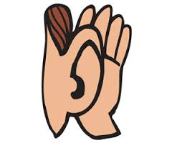



**Revise Edit**

Improve the overall quality of the composition

Help the reader understand what the writer means

Check for

appropriate punctuation

Add an interesting beginning and ending

Add, change, delete,

or rearrange parts of

the composition

Add transition words

Fix the "flow"--organize ideas so it makes sense

Use stronger words

Make sure the

right words are capitalized

Correct misspelled words

Indent paragraphs